DEPLOY IN KUBERNETES CLUSTER

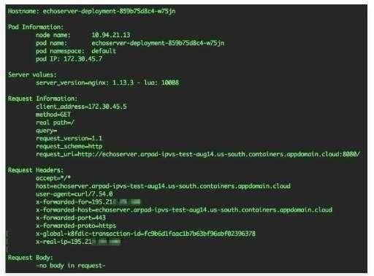

|  |  |
| --- | --- |
| Team ID | PNT2022TMID46979 |
| Project Name | Project - SMART FASHION RECOMMENDER APPLICATION |

